**Pemrogramman 4**

**praktikum 7**

**Nama : Muhammad Sidratul Muntaha**

**Npm : 4510210013**

**ScreenShoot**

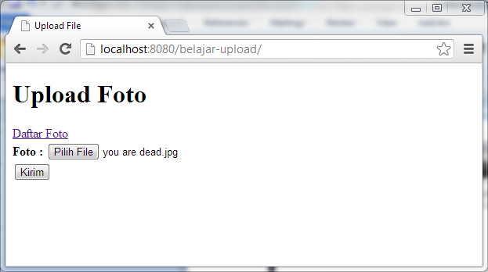

**Gambar 1.** Input Foto

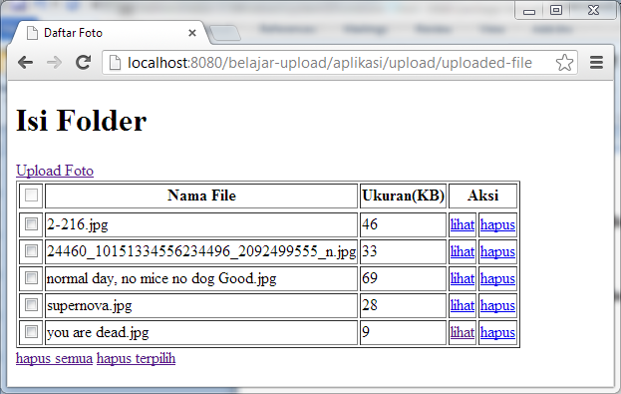

**Gambar 2.** Daftar File

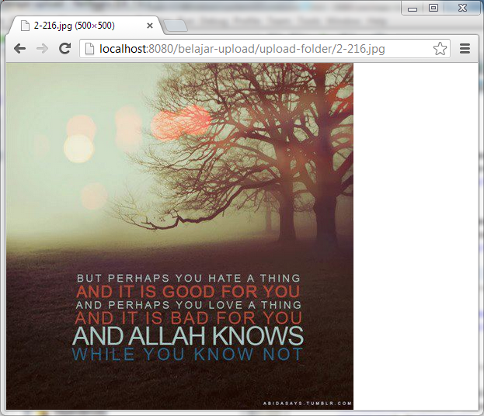

**Gambar 3.** Lihat Gambar

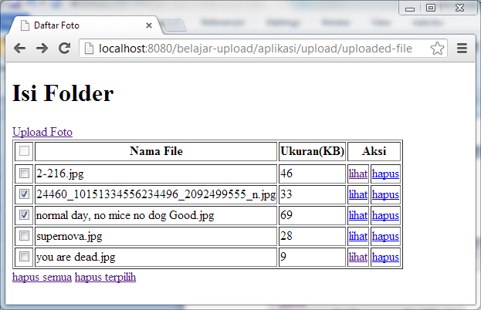

**Gambar 4.** Hapus Foto Yang Dipilih

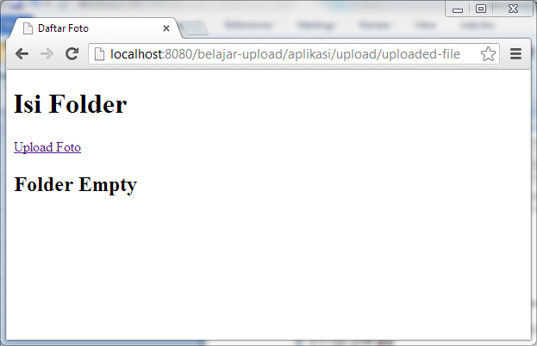

**Gambar 5.** Hapus Semua

**SourceCode**

**Pom.xml**

|  |
| --- |
| <project xmlns="http://maven.apache.org/POM/4.0.0" xmlns:xsi="http://www.w3.org/2001/XMLSchema-instance"  xsi:schemaLocation="http://maven.apache.org/POM/4.0.0 http://maven.apache.org/xsd/maven-4.0.0.xsd">  <modelVersion>4.0.0</modelVersion>  <groupId>com.p4.upload</groupId>  <artifactId>belajar-upload</artifactId>  <version>1.0-SNAPSHOT</version>  <packaging>war</packaging>  <name>belajar-upload</name>  <url>http://maven.apache.org</url>  <properties>  <project.build.sourceEncoding>UTF-8</project.build.sourceEncoding>  </properties>  <dependencies>  <dependency>  <groupId>junit</groupId>  <artifactId>junit</artifactId>  <version>3.8.1</version>  <scope>test</scope>  </dependency>  <dependency>  <groupId>javax.servlet</groupId>  <artifactId>javax.servlet-api</artifactId>  <version>3.0.1</version>  <scope>provided</scope>  </dependency>  <dependency>  <groupId>javax.servlet</groupId>  <artifactId>jstl</artifactId>  <version>1.2</version>  </dependency>    <dependency>  <groupId>org.springframework</groupId>  <artifactId>spring-webmvc</artifactId>  <version>3.2.2.RELEASE</version>  </dependency>  <dependency>  <groupId>org.springframework</groupId>  <artifactId>spring-context</artifactId>  <version>3.2.2.RELEASE</version>  </dependency>    <!-- Apache Commons Upload -->  <dependency>  <groupId>commons-io</groupId>  <artifactId>commons-io</artifactId>  <version>2.4</version>  </dependency>  <!-- Apache Commons Upload -->  <dependency>  <groupId>commons-fileupload</groupId>  <artifactId>commons-fileupload</artifactId>  <version>1.3</version>  </dependency>  </dependencies>  </project> |

**Web.xml**

|  |
| --- |
| <?xml version="1.0" encoding="UTF-8"?>  <web-app xmlns="http://java.sun.com/xml/ns/javaee"  xmlns:xsi="http://www.w3.org/2001/XMLSchema-instance"  xsi:schemaLocation="http://java.sun.com/xml/ns/javaee http://java.sun.com/xml/ns/javaee/web-app_3_0.xsd"  version="3.0">    <servlet>  <servlet-name>upload</servlet-name>  <servlet-class>org.springframework.web.servlet.DispatcherServlet</servlet-class>  <load-on-startup>1</load-on-startup>  </servlet>  <servlet-mapping>  <servlet-name>upload</servlet-name>  <url-pattern>/aplikasi/*</url-pattern>  </servlet-mapping>  <welcome-file-list>  <welcome-file>aplikasi/upload/upload-gambar</welcome-file>  </welcome-file-list>  </web-app> |

**upload-servlet.xml**

|  |
| --- |
| <?xml version="1.0" encoding="UTF-8"?>  <beans xmlns="http://www.springframework.org/schema/beans"  xmlns:mvc="http://www.springframework.org/schema/mvc"  xmlns:context="http://www.springframework.org/schema/context"  xmlns:xsi="http://www.w3.org/2001/XMLSchema-instance"  xsi:schemaLocation="  http://www.springframework.org/schema/beans  http://www.springframework.org/schema/beans/spring-beans.xsd  http://www.springframework.org/schema/context  http://www.springframework.org/schema/context/spring-context.xsd  http://www.springframework.org/schema/mvc  http://www.springframework.org/schema/mvc/spring-mvc.xsd">  <context:component-scan base-package="com.p4.upload"/>  <mvc:annotation-driven />    <bean id="jspViewResolver" class="org.springframework.web.servlet.view.InternalResourceViewResolver">  <property name="viewClass" value="org.springframework.web.servlet.view.JstlView"/>  <property name="prefix" value="/WEB-INF/template/jsp/"/>  <property name="suffix" value=".jsp"/>  </bean>    <bean id="multipartResolver"  class="org.springframework.web.multipart.commons.CommonsMultipartResolver">  <property name="maxUploadSize" value="1000000" />  </bean>  </beans> |

**FileUpload.java**

|  |
| --- |
| package com.p4.upload;  public class FileUpload {  private String namaFile;  private Long ukuranFile;  public String getNamaFile() {  return namaFile;  }  public void setNamaFile(String namaFile) {  this.namaFile = namaFile;  }  public Long getUkuranFile() {  return ukuranFile;  }  public void setUkuranFile(Long ukuranFile) {  this.ukuranFile = ukuranFile;  }    } |

**UploadController.java**

|  |
| --- |
| package com.p4.upload;  import java.io.File;  import java.util.ArrayList;  import java.util.List;  import org.springframework.stereotype.Controller;  import org.springframework.ui.ModelMap;  import org.springframework.web.bind.annotation.RequestMapping;  import org.springframework.web.bind.annotation.RequestMethod;  import org.springframework.web.bind.annotation.RequestParam;  import org.springframework.web.multipart.MultipartFile;  @Controller  public class UploadController {    @RequestMapping(value="upload/upload-gambar", method= RequestMethod.GET)  public void tampilForm(){  System.out.println("menampilkan form");  }    @RequestMapping(value="upload/upload-gambar", method= RequestMethod.POST)  public String prosesForm(@RequestParam("photofile") MultipartFile fileUpload )throws Exception{  String namaFile = fileUpload.getOriginalFilename();  File file = new File("src/main/webapp/upload-folder/"+namaFile);  fileUpload.transferTo(file);  return "redirect:/aplikasi/upload/uploaded-file";  }    @RequestMapping("upload/uploaded-file")  public ModelMap tampilFile(){  List<FileUpload> lFile = new ArrayList<FileUpload>();  String direktori="src/main/webapp/upload-folder/";  File folder=new File(direktori);  File[] lisGambar = folder.listFiles();  for (File file : lisGambar){  if(file.isFile()){  FileUpload ofu = new FileUpload();  ofu.setNamaFile(file.getName());  ofu.setUkuranFile(file.length()/1024);  lFile.add(ofu);  }  }  ModelMap mm = new ModelMap();  mm.addAttribute("listFile", lFile);  return mm;  }    @RequestMapping("upload/hapus-file")  public String hapusFile(@RequestParam("namaFile") String namaFile){  File file = new File("src/main/webapp/upload-folder/"+namaFile);  boolean hapus = file.delete();  if(hapus){  System.out.println("hapus berhasil");  }else{  System.out.println("hapus gagal");  }    return "redirect:uploaded-file";  }    @RequestMapping("upload/hapus-semua-file")  public String hapusSemuaFile(){  String direktori="src/main/webapp/upload-folder/";  File folder=new File(direktori);  File[] lisGambar = folder.listFiles();  for (File file : lisGambar){  if(file.isFile()){  File namaFile = new File(file.getName());  boolean hapus = file.delete();  }  }    return "redirect:uploaded-file";  }    @RequestMapping(value="upload/hapus-semua-file",method= RequestMethod.POST)  public String hapusPilihanFile(@RequestParam("filePilihan") String[] filePilihan){  if(filePilihan==null){  return "redirect:uploaded-file";  }    for (String nama : filePilihan) {  File nameFile = new File("src/main/webapp/upload-folder/"+nama);  Boolean hapus = nameFile.delete();  }  return "redirect:uploaded-file";  }  } |

**Upload-gambar.jsp**

|  |
| --- |
| <%--  Document : index  Created on : May 17, 2013, 2:09:47 PM  Author : Muhammad Sidratul M  --%>  <%@page contentType="text/html" pageEncoding="UTF-8"%>  <%@taglib prefix="c" uri="http://java.sun.com/jsp/jstl/core" %>  <!DOCTYPE html>  <html>  <head>  <meta http-equiv="Content-Type" content="text/html; charset=UTF-8">  <title>Upload File</title>  </head>  <body>  <h1>Upload Foto</h1>  <c:if test="${!empty pesan}">  <h3><c:out value="${pesan}"/></h3>  </c:if>    <a href="<%= request.getContextPath() %>/aplikasi/upload/uploaded-file">Daftar Foto</a>    <form method="POST" enctype="multipart/form-data">  <strong>Foto : </strong><input type="file" name="photofile" accept="image/*"/><br/>  <input type="submit" value="Kirim"/>  </form>  </body>  </html> |

**Uploaded-file.jsp**

|  |
| --- |
| <%--  Document : uploaded-file  Created on : May 17, 2013, 3:27:45 PM  Author : Muhammad Sidratul M  --%>  <%@ taglib prefix="c" uri="http://java.sun.com/jsp/jstl/core" %>  <%@page contentType="text/html" pageEncoding="UTF-8"%>  <!DOCTYPE html>  <html>  <head>  <meta http-equiv="Content-Type" content="text/html; charset=UTF-8">  <title>Daftar Foto</title>  </head>  <body>  <h1>Isi Folder</h1>  <a href="<%= request.getContextPath() %>/aplikasi/upload/upload-gambar">Upload Foto</a>  <c:choose>  <c:when test="${empty listFile}">  <h2>Folder Empty</h2>  </c:when>  <c:otherwise>  <table border="1">  <thead>  <tr>  <th><input type="checkbox" disabled></th>  <th>Nama File</th>  <th>Ukuran(KB)</th>  <th colspan="2">Aksi</th>  </tr>  </thead>  <form action="hapus-semua-file" method="POST" id="checkForm">  <tbody>  <c:forEach items="${listFile}" var="lf">  <tr>  <td><input type="checkbox" name="filePilihan" value="${lf.namaFile}"></td>  <td>${lf.namaFile}</td>  <td>${lf.ukuranFile}</td>  <td><a href="<%= request.getContextPath() %>/upload-folder/${lf.namaFile}">lihat</a></td>  <td><a href="hapus-file?namaFile=${lf.namaFile}">hapus</a></td>  </tr>  </c:forEach>  </tbody>  </form>  </table>  <a href="hapus-semua-file">hapus semua</a> <a href="#" onclick="submitForm()">hapus terpilih</a>  </c:otherwise>  </c:choose>  <script>  function submitForm(){  var a = document.getElementById("checkForm");  a.submit();  }  </script>  </body>  </html> |